- In generate bill page - if patient is not registered, the user should see an option to “register new patient” below
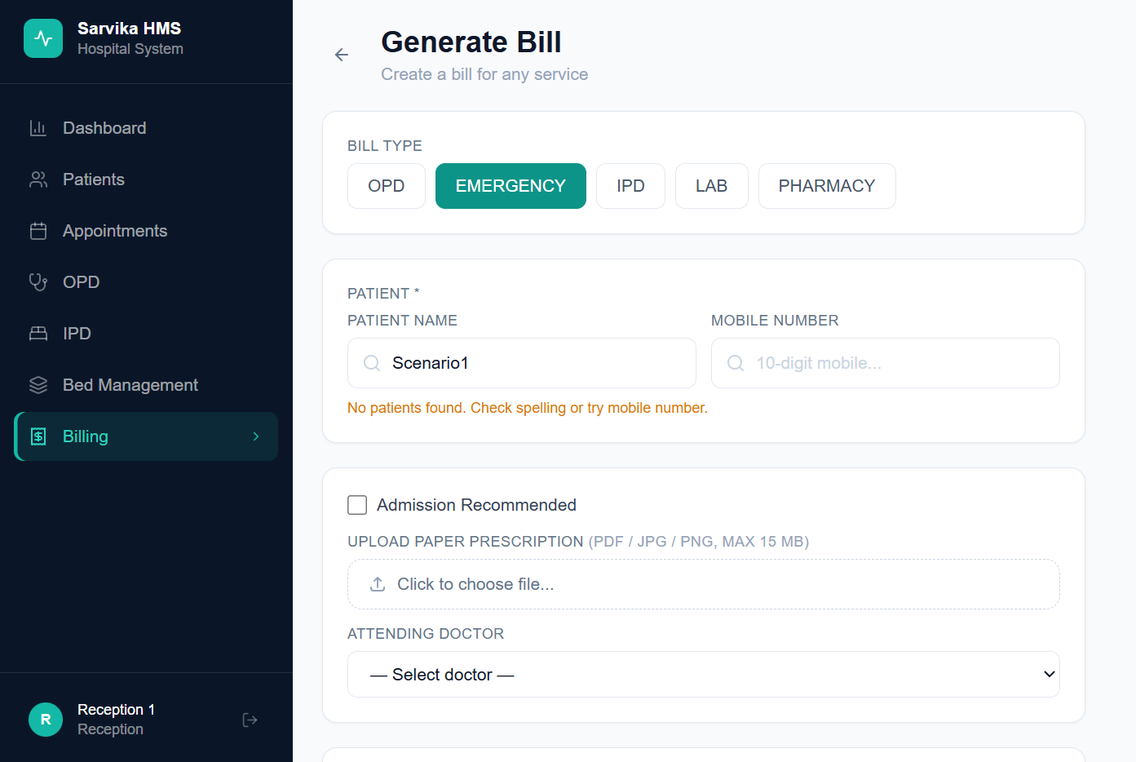
- In “generate bill” page – in “bill items” the “medicine” type should be dropdown from pre-filled list with price
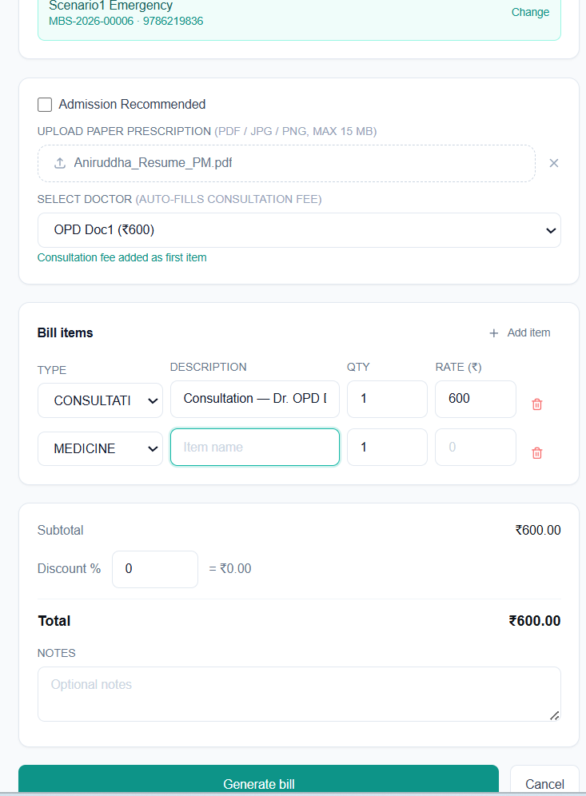
- In Nurse Screen (when a nurse logs in) – If a patient is transferred from emergency, that is, if patient have a transferred emergency bill – then in the patient overview page – the nurse should also be able to see the emergency prescription and notes and doctor name only without any bill or price.
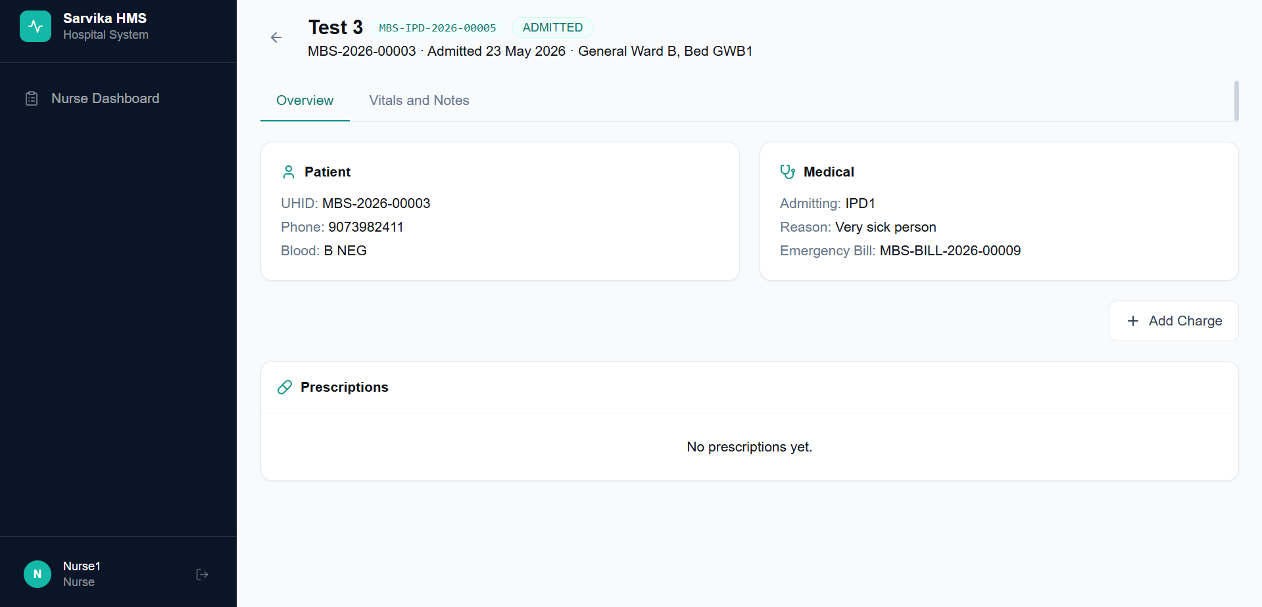
- One Critical Update: I am trying to describe it functionally through a scenario:
Scenario 1: When a patient is getting admitted through Emergency:
The existing workflow remains – the receptionist goes to billing page -> generate bill -> selects bill type “Emergency” ->
In such above scenarios – the Doctor selected in “Select Doctor” field – becomes the admitting doctor

Scenario 2: Patient getting admitted through normal “New Admission” Page from the IPD Page – the admitting doctor’s consultation fee gets added to the new ongoing bill that is created for the Patient’s IPD admission

- Screen: Nurse
The “Add Charge” page should be corrected – It should be similar to the logic of “Bill Items” section of “Generate Bill” Page, wherein:
- “Consultation” Type – would allow the user to select doctors across OPD/Emergency/IPD/Admitting Doctor or the user can also select “Special doctor” – and write the doctor’s name in a free text type box
- “Consumable” and “Medicine” Type – would let the user select from a dropdown (prefilled consumables/medicines list)
- “Procedure” and “Others” type – would let the user type anything in the text box that appears
